

**How to load a datalog config file to your device.**

From your email, click on the arrow, then click save as. Plug your tuner into your computer and open the SCT Device Updater.

Select“Transfer File to Device”

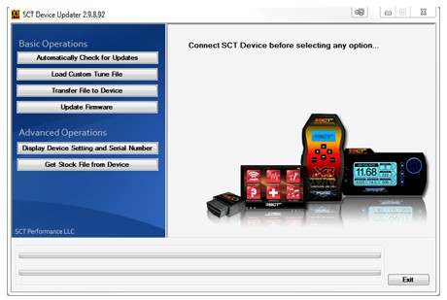

Click Browse and select the .dlx file you just saved.

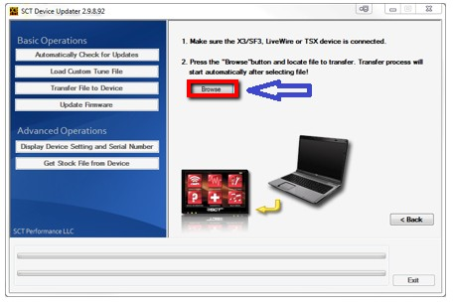

You'll see a window that will display when it's complete. You can now unplug the device and take it to your vehicle to perform a datalog.

How to record your Datalog on the SCT device:

Plug the OBDII Cable into the OBDII Port and into the tuner.

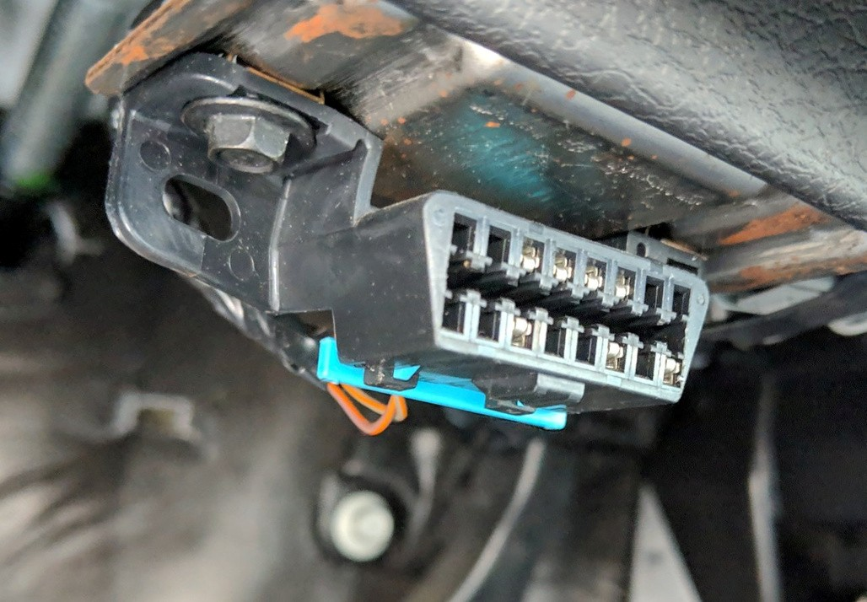

On the X4 Tuner, highlight the Gauges/Datalog menu, and then click the center button.

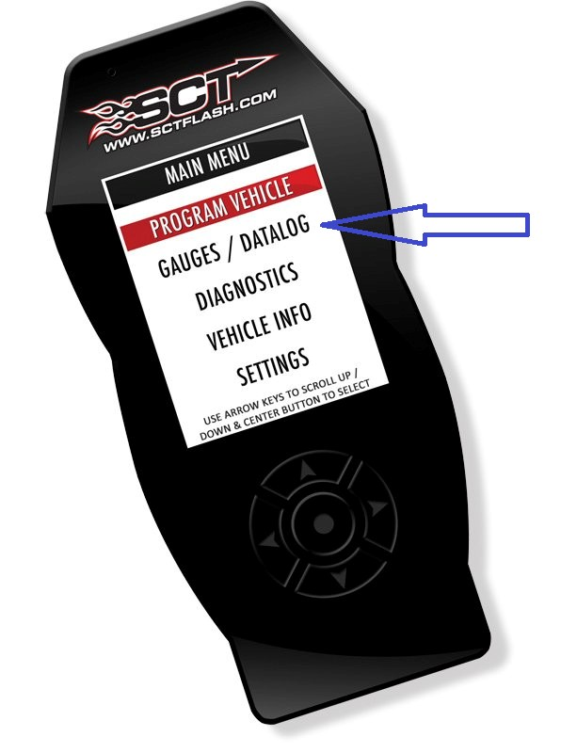

Turn key to on, select configuration by clicking the left arrow, then click the center

"Configuration" button.

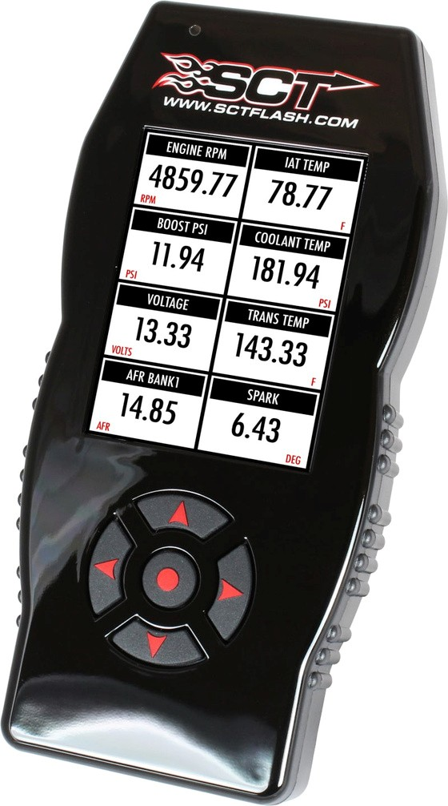

Select the configuration file name you chose above. Hit the center red botton on the

device to start and stop data recording. It will only record one file at a time.

Select “I want to import a datalog from a device”.

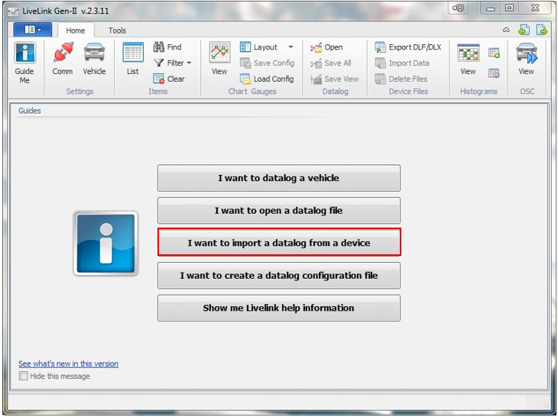

Next, LiveLink will need to check the communication with the device, hit the check communication button, this may take a minute.

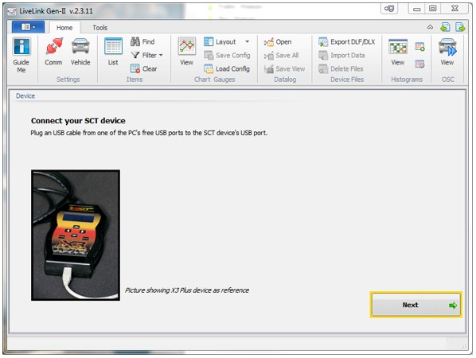

Next, LiveLink will need to check the communication with the device, hit the check

communication button, this may take a minute. Once the information is confirmed click

Import File.

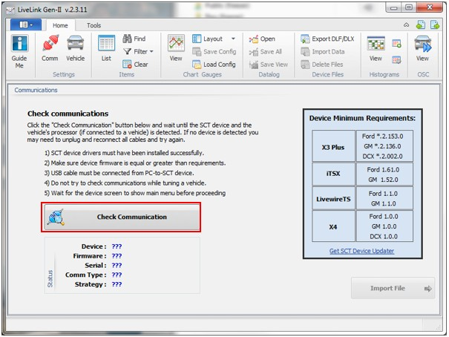

You will be taken to a screen that shows a graph of the data captured during your

session. Save your datalog as a .CSV file by going to the top menu and selecting “Save

All”.

